Hexagonal Trapezohedron

Definition
# Source: AI Source: Provided by: [Data Path: Persons Table -> ID Column: 1, Name_En Column: Motasem Essam] -> From: [ChatGPT] on [7/25/2026]
A Hexagonal Trapezohedron is a convex polyhedron consisting of 12 congruent kite-shaped faces, arranged symmetrically around a central sixfold rotational axis.
It has two opposite axial vertices (one at each end of the axis) and six vertices forming a middle ring.
It is also called a Hexagonal Deltohedron.

Simple Definition
# Source: AI Source: Provided by: [Data Path: Persons Table -> ID Column: 1, Name_En Column: Motasem Essam] -> From: [ChatGPT] on [7/25/2026]
A hexagonal trapezohedron is a three-dimensional solid made of twelve identical kite-shaped faces arranged around a central axis, with six vertices forming a ring around its middle.
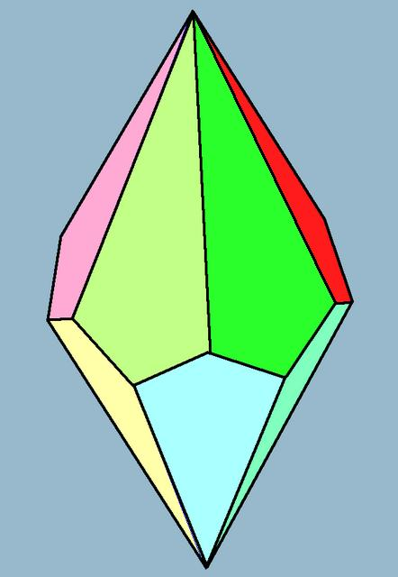

Geometric Structure
# Source: AI Source: Provided by: [Data Path: Persons Table -> ID Column: 1, Name_En Column: Motasem Essam] -> From: [ChatGPT] on [7/25/2026]
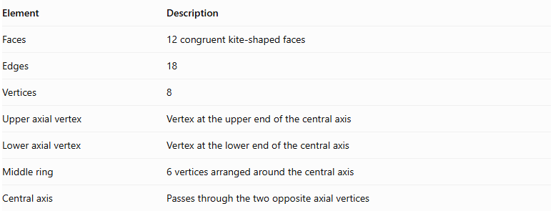
Element | Description
Faces | 12 congruent kite-shaped faces
Edges | 18
Vertices | 8
Upper axial vertex | Vertex at the upper end of the central axis
Lower axial vertex | Vertex at the lower end of the central axis
Middle ring | 6 vertices arranged around the central axis
Central axis | Passes through the two opposite axial vertices

Face Structure
# Source: AI Source: Provided by: [Data Path: Persons Table -> ID Column: 1, Name_En Column: Motasem Essam] -> From: [ChatGPT] on [7/25/2026]
Each face is a kite-shaped quadrilateral characterized by:
- Two pairs of adjacent equal-length sides.
- One pair of equal opposite angles.
- Perpendicular diagonals.
- One diagonal that bisects the other.
All twelve faces are congruent and form a closed convex surface.

Edge Structure
# Source: AI Source: Provided by: [Data Path: Persons Table -> ID Column: 1, Name_En Column: Motasem Essam] -> From: [ChatGPT] on [7/25/2026]
The 18 edges can be classified into three groups:
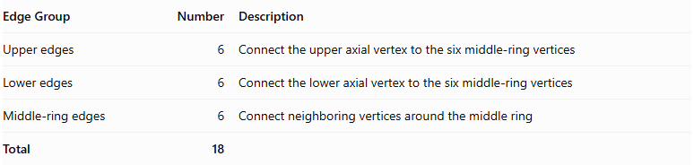
Edge Group | Number | Description
Upper edges | 6 | Connect the upper axial vertex to the six middle-ring vertices
Lower edges | 6 | Connect the lower axial vertex to the six middle-ring vertices
Middle-ring edges | 6 | Connect neighboring vertices around the middle ring
Total | 18

Vertex Structure
# Source: AI Source: Provided by: [Data Path: Persons Table -> ID Column: 1, Name_En Column: Motasem Essam] -> From: [ChatGPT] on [7/25/2026]
The hexagonal trapezohedron has eight vertices:
- 1 upper axial vertex.
- 1 lower axial vertex.
- 6 middle-ring vertices.
$$V=2+6=8$$
In its standard symmetric form:
- Six faces meet at each axial vertex.
- Four faces meet at each middle-ring vertex.

Mathematical Properties
# Source: AI Source: Provided by: [Data Path: Persons Table -> ID Column: 1, Name_En Column: Motasem Essam] -> From: [ChatGPT] on [7/25/2026]
For a hexagonal trapezohedron, $n=6$.

A. Number of Faces
# Source: AI Source: Provided by: [Data Path: Persons Table -> ID Column: 1, Name_En Column: Motasem Essam] -> From: [ChatGPT] on [7/25/2026]
$$F=2n=2(6)=12$$

B. Number of Edges
# Source: AI Source: Provided by: [Data Path: Persons Table -> ID Column: 1, Name_En Column: Motasem Essam] -> From: [ChatGPT] on [7/25/2026]
$$E=3n=3(6)=18$$

C. Number of Vertices
# Source: AI Source: Provided by: [Data Path: Persons Table -> ID Column: 1, Name_En Column: Motasem Essam] -> From: [ChatGPT] on [7/25/2026]
$$V=n+2=6+2=8$$

D. Euler's Formula
# Source: AI Source: Provided by: [Data Path: Persons Table -> ID Column: 1, Name_En Column: Motasem Essam] -> From: [ChatGPT] on [7/25/2026]
$$V-E+F=2$$
$$8-18+12=2$$
<badge color="success">Verified</badge> Euler's formula is satisfied.

Symmetry
# Source: AI Source: Provided by: [Data Path: Persons Table -> ID Column: 1, Name_En Column: Motasem Essam] -> From: [ChatGPT] on [7/25/2026]
A standard symmetric hexagonal trapezohedron has:
- A sixfold rotational symmetry axis.
- Sixfold rotational symmetry around its central axis.
- Six vertical reflection planes containing the central axis.
- Central inversion symmetry when its upper and lower portions are arranged symmetrically.

Constructing Hexagonal Trapezohedron in Solid Geometry

Geometric Instruments Used
# Source: AI Source: Provided by: [Data Path: Persons Table -> ID Column: 1, Name_En Column: Motasem Essam] -> From: [ChatGPT] on [7/25/2026]
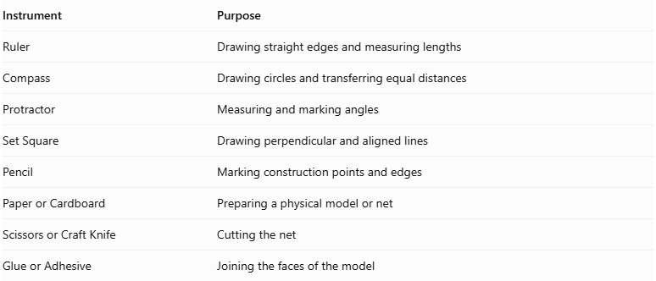
Instrument | Purpose
Ruler | Drawing straight edges and measuring lengths
Compass | Drawing circles and transferring equal distances
Protractor | Measuring and marking angles
Set Square | Drawing perpendicular and aligned lines
Pencil | Marking construction points and edges
Paper or Cardboard | Preparing a physical model or net
Scissors or Craft Knife | Cutting the net
Glue or Adhesive | Joining the faces of the model

Instrument-Based Construction Procedures
# Source: AI Source: Provided by: [Data Path: Persons Table -> ID Column: 1, Name_En Column: Motasem Essam] -> From: [ChatGPT] on [7/25/2026]
The hexagonal trapezohedron can be constructed using geometric instruments through a symmetry-based drawing process.

Preparing the Central Axis
# Source: AI Source: Provided by: [Data Path: Persons Table -> ID Column: 1, Name_En Column: Motasem Essam] -> From: [ChatGPT] on [7/25/2026]
- Draw a vertical reference line representing the central axis.
- Mark the intended upper and lower axial vertices.
- Establish the central region where the two staggered vertex rings will be positioned.

Constructing the Two Vertex Rings
# Source: AI Source: Provided by: [Data Path: Persons Table -> ID Column: 1, Name_En Column: Motasem Essam] -> From: [ChatGPT] on [7/25/2026]
- Use a compass to draw the reference circles for the upper and lower rings.
- Divide each circle into six equally spaced positions.
- Use a protractor to mark the six positions at equal angular intervals of ${60}^{∘}$.
- Offset the second ring relative to the first to create the staggered arrangement.
- Mark the six vertices on each ring.

Marking the Axial Vertices
# Source: AI Source: Provided by: [Data Path: Persons Table -> ID Column: 1, Name_En Column: Motasem Essam] -> From: [ChatGPT] on [7/25/2026]
- Mark the upper axial vertex above the upper ring.
- Mark the lower axial vertex below the lower ring.
- Align both vertices with the central axis.

Constructing the Kite-Shaped Faces
# Source: AI Source: Provided by: [Data Path: Persons Table -> ID Column: 1, Name_En Column: Motasem Essam] -> From: [ChatGPT] on [7/25/2026]
- Connect the upper axial vertex to the appropriate vertices of the upper and lower rings.
- Connect the lower axial vertex to the corresponding vertices of the two rings.
- Join neighboring vertices from the two rings according to the trapezohedron's face arrangement.
- Form twelve kite-shaped quadrilateral faces.
- Check that all shared edges have matching lengths and that the faces close into a convex solid.

Completing the Three-Dimensional Drawing
# Source: AI Source: Provided by: [Data Path: Persons Table -> ID Column: 1, Name_En Column: Motasem Essam] -> From: [ChatGPT] on [7/25/2026]
- Draw the visible edges using continuous lines.
- Represent hidden edges using dashed lines when necessary.
- Check that all twelve faces are connected correctly.
- Verify that the drawing contains 14 vertices and 24 edges.

Constructing a Physical Model
# Source: AI Source: Provided by: [Data Path: Persons Table -> ID Column: 1, Name_En Column: Motasem Essam] -> From: [ChatGPT] on [7/25/2026]
- Draw a valid net containing twelve correctly connected kite-shaped faces.
- Add tabs along selected outer edges.
- Cut out the net carefully.
- Fold along the shared face boundaries.
- Join corresponding edges using adhesive.
- Check that the assembled model forms a closed hexagonal trapezohedron.
Construction note: This is an instrument-based geometric construction using rulers, compasses, protractors, and geometric relationships. It does not use coordinate-based construction.

Relationship to Other Trapezohedra
# Source: AI Source: Provided by: [Data Path: Persons Table -> ID Column: 1, Name_En Column: Motasem Essam] -> From: [ChatGPT] on [7/25/2026]
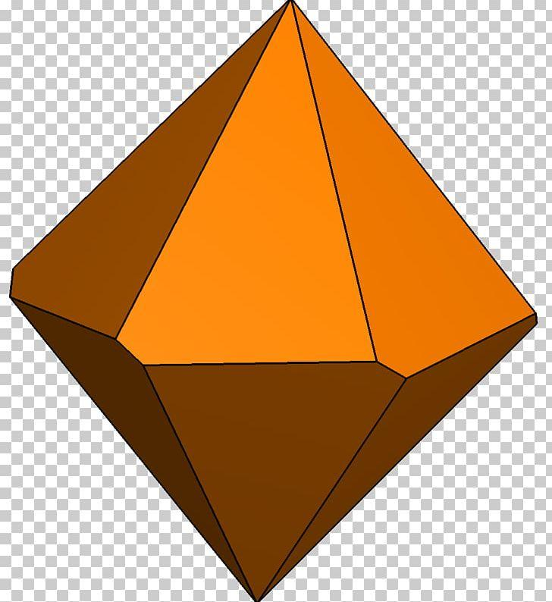
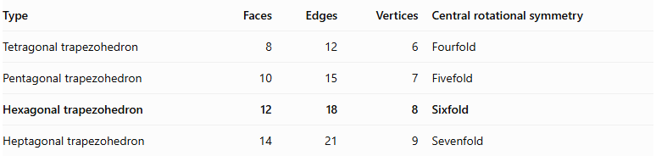
Type | Faces | Edges | Vertices | Central rotational symmetry
Tetragonal trapezohedron | 8 | 12 | 6 | Fourfold
Pentagonal trapezohedron | 10 | 15 | 7 | Fivefold
Hexagonal trapezohedron | 12 | 18 | 8 | Sixfold
Heptagonal trapezohedron | 14 | 21 | 9 | Sevenfold

Applications
# Source: AI Source: Provided by: [Data Path: Persons Table -> ID Column: 1, Name_En Column: Motasem Essam] -> From: [ChatGPT] on [7/25/2026]
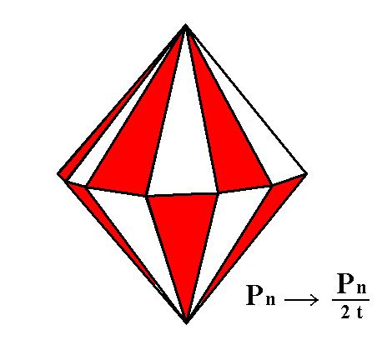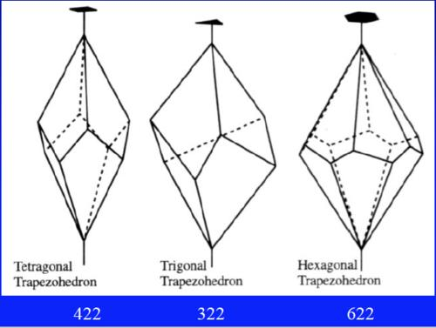
- Dice: The twelve-sided die (D12) is commonly modeled using a pentagonal trapezohedron, not a hexagonal one. A hexagonal trapezohedron has twelve kite-shaped faces but is not the standard D12 shape.
- Crystallography: Trapezohedral forms occur in crystal symmetry classifications.
- Mathematical geometry: Useful for studying polyhedral symmetry and face arrangements.
- Geometric modeling: Used in constructing rotationally symmetric solids.

Key Points
# Source: AI Source: Provided by: [Data Path: Persons Table -> ID Column: 1, Name_En Column: Motasem Essam] -> From: [ChatGPT] on [7/25/2026]
- A hexagonal trapezohedron has 12 congruent kite-shaped faces.
- It has 18 edges and 8 vertices.
- Six vertices form its middle ring.
- Two vertices lie at opposite ends of its central axis.
- Its standard symmetric form has a sixfold rotational axis.
- It satisfies Euler's polyhedron formula.

Conclusion
# Source: AI Source: Provided by: [Data Path: Persons Table -> ID Column: 1, Name_En Column: Motasem Essam] -> From: [ChatGPT] on [7/25/2026]
The Hexagonal Trapezohedron is the sixfold form of a trapezohedron, consisting of twelve congruent kite-shaped faces arranged around a central axis. It has eight vertices, eighteen edges, and sixfold rotational symmetry.
Classification note: The hexagonal trapezohedron is topologically equivalent to a bipyramid over a hexagon, but its faces are kite-shaped quadrilaterals rather than triangles.

